**Understanding Calculus:**

**A Junior-High Level Approach to the Ideas of Derivatives and Integrals**

15 November 2018

Prepared by Brian Nguyen

Prepared for 5th grade teachers and up

Prepared for Jason Charnesky

The Pennsylvania State University

Table of Contents

**Introduction** 3

**0.1 Why is understanding the ideas of derivatives and integrals is important for kids at this age?** 3

**0.2 What is infinity?** 3

**Figure 0.1:** Table Showing Infinite Different Numbers between the Numbers 1 and 2 3

**Figure 0.2:** Set of Pictures Showing Circles Being Divided into Smaller Slices 4

**What is a “derivative?”** 5

**1.0 A Simplified Definition of a Derivative** 5

**1.1 Understanding What a Derivative Is with Visuals** 5

**Figure 1.1:** Linear Graph with Slope of -1 5

**Figure 1.2:** Graph with Point at (1, 0.1353) 5

**Figure 1.3:** A Zoomed-In View of Figure 1.2 6

**Figure 1.4:** Pictures Showing More Zoomed-In Views of Figure 1.2 (zoom increases from a to c) 6

**Figure 1.5:** Derivatives at Different Parts of Curve 7

**Figure 1.6:** Different Slopes for Neighboring Pairs of Infinitely Close Points 7

**What is an “integral?”** 8

**2.0 A Simplified Definition of an Integral** 8

**2.1 Understanding What an Integral Is with Visuals** 8

**Figure 1.1:** Linear Graph with Slope of -1 8

**Figure 2.1:** Graph with Highlighted Section Showing Area of Graph 8

**Eq. 1:** Area of a Triangle 9

**Figure 2.2:** Estimating Area of Graph Using Quarters 9

**Figure 2.3:** Estimating Area of Graph Using Nickels 10

**Figure 2.4:** Estimating Area of Graph Using Dimes 10

**Figure 2.5:** Pictures Showing Rectangles Filling Area Under the Curve 11

**Figure 2.6:** Infinitely Large Number of Rectangles Under the Curve 11

**Summary** 12

# **Introduction**

Within each of us there is a desire to seek knowledge and understand the world around us. Kids especially are constantly pondering about the mysteries of the world around them. Mathematics is one such way of unraveling and understanding those mysteries. You do not think about it, but you, and everyone else, utilize the principles of mathematics every day, whether it be from simply counting the number of objects in your hand or designing a full-fledged rocket. Often times, math becomes misconceived with calculations, but math itself is not about calculations. It is about understanding and applying concepts and processes.

## **0.1 Why is understanding the ideas of derivatives and integrals is important for kids at this age?**

Calculus is a branch of mathematics that is revered for its difficulty and rigor; however, its fundamental concepts can be understood by almost anyone, even children. It is especially important that children begin to think about the ideas of calculus because without an understanding of these ideas, understanding its applications will be increasingly more difficult, if not impossible. The rigor associated from the algebra and computations involved in calculus can be learned through time and practice.

## **0.2 What is infinity?**

Before we delve into what the concept of derivatives and integrals are, it is important that we take a step back and re-examine the meaning of the word “infinity.” Infinity is sometimes termed as the biggest “number” possible; however, a number is finite. In other words, it has a value and it is limited by that value. For example, the number, 1, has a value and only that value. The number, 2, also has a value and only that value. It is essentially two 1s together. The number, 3, is three 1s together, and so forth. But what is a number with an uncountable large amount of 1s together? That number would be termed as being a number with infinite 1s, but it is not infinity. That number is infinitely large. If finite means to be limited and bounded, then infinite would mean to be unlimited and unbounded; therefore, infinity cannot be a number because it is unbounded and unlimited.

If I asked you to count the total amount of different numbers between one and two, it would be impossible because there exists an infinite amount of numbers in between the numbers, one and two. 1 is a number, but so is 1.1 and 1.11 and 1.111 and so forth. If we keep adding a one to the end of the previous number, we get a different number that is a little bigger than the previous number but still less than 2. As seen in Figure 1 below, if we keep counting the total amount of these numbers before reaching 2, the count will never end. That is the concept of infinity.

|  |  |  |  |  |  |  |  |  |  |
| --- | --- | --- | --- | --- | --- | --- | --- | --- | --- |
| **Count** | 1 | 2 | 3 | 4 | 5 | 6 | 7 | 8 | … |
| **Numbers** | 1 | 1.1 | 1.11 | 1.111 | 1.1111 | 1.11111 | 1.11111 | 1.1111111 | 1.11111111… |

### **Figure 0.1:** Table Showing Infinite Different Numbers between the Numbers 1 and 2

Infinity can also be used to describe something that is extremely small. Let’s take cutting a circle for example. As seen in Figure 2a below, we start with one whole circle, but if we cut it down the middle, we now have half of a circle, or ½. If we divide the circle into thirds, we have three pieces. If we continue cutting the circle, we will get more and more slices, but each slice gets smaller and smaller as seen in the figure below.

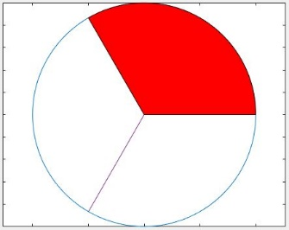

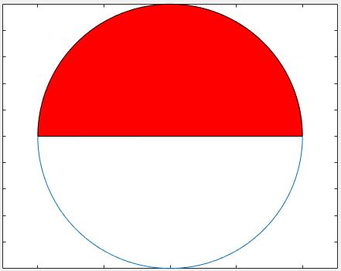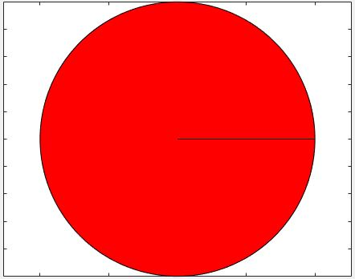

c = 1/3

a = 1

b = 1/2

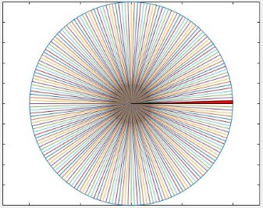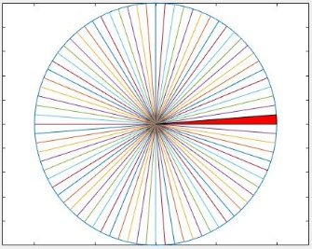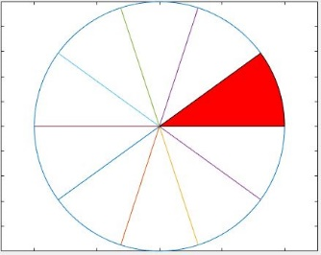

f = 1/200

e = 1/80

d = 1/10

### **Figure 0.2:** Set of Pictures Showing Circles Being Divided into Smaller Slices

As the slice get smaller, it will eventually reach a point when it is so small that you can’t see it. At that point, it is as if the slice is not there, but we know that it still there. It essentially zero, but not yet at zero. The slice would be 1/∞ of the circle. The slice would then be as described as being infinitely small, or infinitesimal.

# **What is a “derivative?”**

## **1.0 A Simplified Definition of a Derivative**

A derivative is one of the critical ideas belonging to Calculus, a branch of mathematics. A derivative can be thought of as the change between two infinitely close points. In mathematics, it is thought of as the slope between two infinitely close points on a graph.

## **1.1 Understanding What a Derivative Is with Visuals**

Let’s take a look at some graphs to help visualize the concept of a derivative. We are familiar with straight lines having slopes as seen in Figure 1.1 below with a slope of -1.

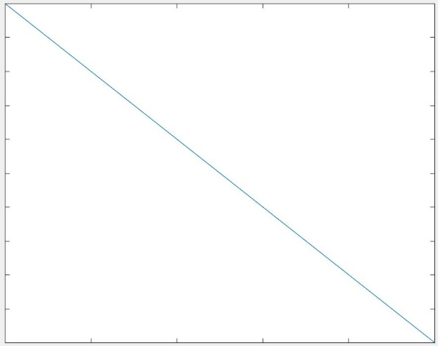

### **Figure 1.1:** Linear Graph with Slope of -1

But what if we had a graph that was not a straight line? Looking at Figure 1.2 below, we have such a graph. Focus on the fact that the graph is curved and does not have a constant slope like the previous graph.

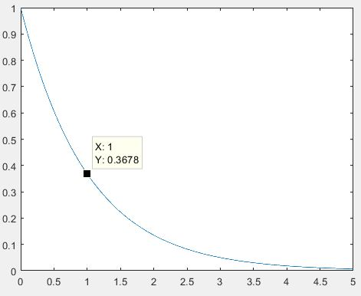

### **Figure 1.2:** Graph with Point at (1, 0.1353)

As stated before, a derivative can be thought of as the change between two infinitely close points. Let’s zoom into the graph to see what it looks like.

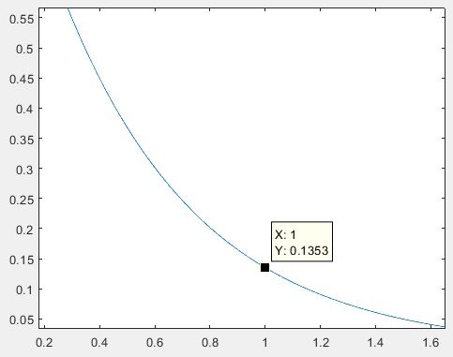

### **Figure 1.3:** A Zoomed-In View of Figure 1.2

Notice from Figure 1.3 that despite being zoomed in, the graph appears to be similar in shape as before. However, if we keep zooming in, we will notice that the graph starts to look more like the straight line in Figure 1.1.

**c**

**b**

**a**

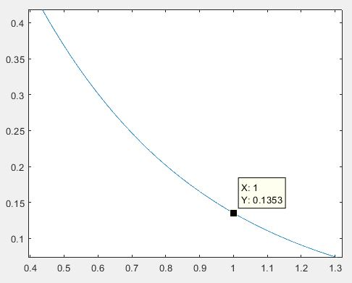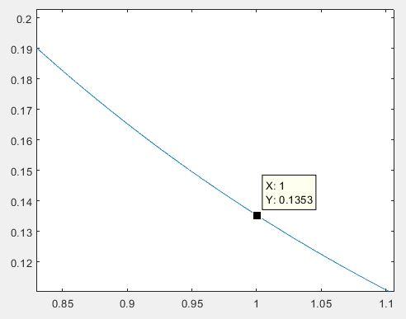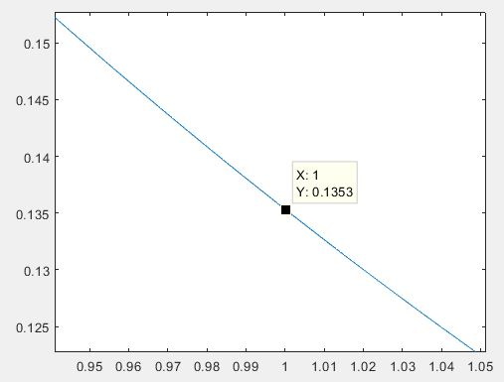

### **Figure 1.4:** Pictures Showing More Zoomed-In Views of Figure 1.2 (zoom increases from a to c)

Now, we can start to see that even through a graph may not be straight, if we zoom in enough, the graph becomes essentially a straight line (Figure 1.4c). From this, we can get a slope, but it would be the slope for a very small part of the graph.

If we were to move around the graph and get the slope at different parts, it would not be the same (Figure 1.5). This makes sense because the graph is originally not straight; it is curved. Therefore, it should have a changing slope.

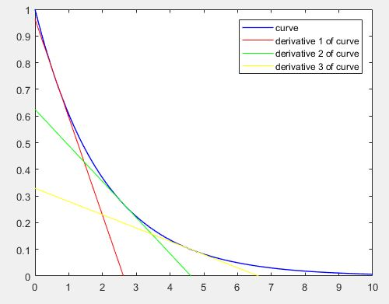

### **Figure 1.5:** Derivatives at Different Parts of Curve

If we tried to zoom in on a straight line, the slope would not change, because the line is not curved. Its slope is constant throughout the line, whereas a curved line will always have a changing slope between different parts of its graph. No matter how close you may zoom in on a curved graph, it will have a different slope for every pair of infinitely close points you take as seen below in Figure 1.6. While the difference between the slopes may be small, perhaps even infinitely small, it is still a difference.

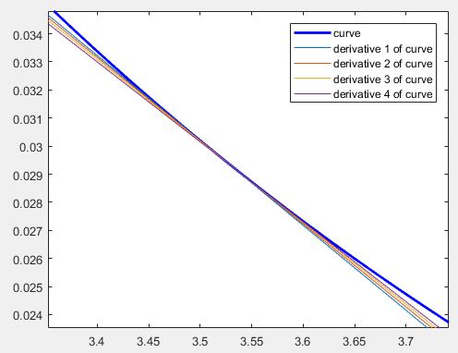

### **Figure 1.6:** Different Slopes for Neighboring Pairs of Infinitely Close Points

As you can see, a derivative is simply the change, or slope, between two really close points. Even the smallest shift in those two points will change the slope of a curve.

# **What is an “integral?”**

## **2.0 A Simplified Definition of an Integral**

An integral is one of the main ideas belonging to Calculus, a branch of mathematics. An integral can be thought of as the total space enclosed by some boundary. In other words, it could be the area of a shape in two-dimensional space, or its volume in three-dimensional space. In mathematics, the definition is generalized to being the area bounded between a curve and its independent axis (often associated with the x-axis).

## **2.1 Understanding What an Integral Is with Visuals**

Let’s take a look at some graphs to help visualize the concept of an integral. We will start out by looking at a simple straight-line graph with a slope of -1 (Figure 1.1) placed below for convenience.

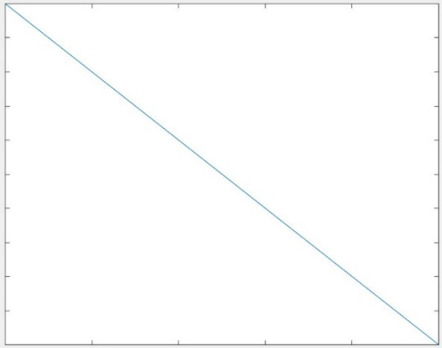

### **Figure 1.1:** Linear Graph with Slope of -1

Now, an integral is defined as the area bounded between a curve and its independent axis. Applying that definition here, we see that our curve is the straight-line above and its x-axis is the horizontal line below the line at the bottom edge of the graph. The area would simply be the space between the line to the x-axis shown below in Figure 2.1 below.

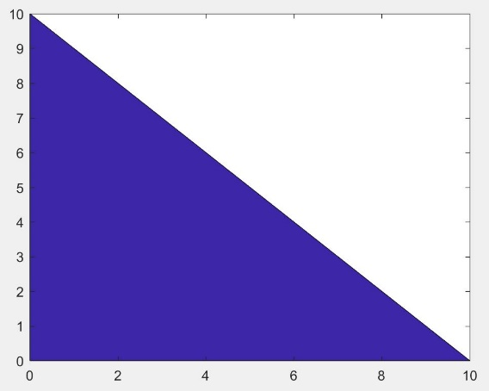

### **Figure 2.1:** Graph with Highlighted Section Showing Area of Graph

As you can see from Figure 2.1, the graph is in the shape of a triangle. As you may know, the area of the triangle is simply:

### **Eq. 1:** Area of a Triangle

You can calculate the area of this curve by it, but let’s try to calculate it another way so we can generalize the process to more shapes and curves than a triangle. Have you ever looked at something and you didn’t know the length of it, so you used an object to approximate the length of that thing? For example, take your bathroom sink at home as the thing to be measured. You don’t know the exact width of it, because you don’t have a ruler on you, so instead you use your toothbrush to get a rough guess of how wide your bathroom sink is. We are going to apply that same idea to finding the area of the graph in Figure 2.1, but instead, we will be using coins. We will first use quarters to get a rough estimate of the graph as seen below in Figure 2.2.

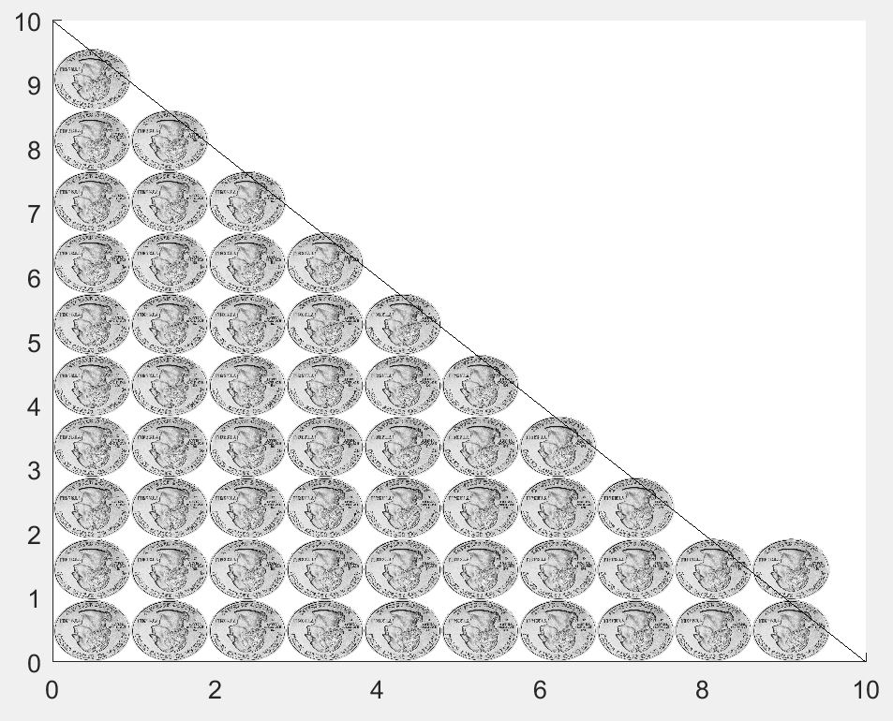

### **Figure 2.2:** Estimating Area of Graph Using Quarters

From Figure 2.2, you can see that we have 56 quarters that roughly make up the area of the triangle, but notice that there are a lot of white spaces in between the quarters that is not being measured by them. This is a problem because the unaccounted space in between the quarters detracts from the accuracy of our area estimation. So, what if we used a smaller coin, like nickels, instead?

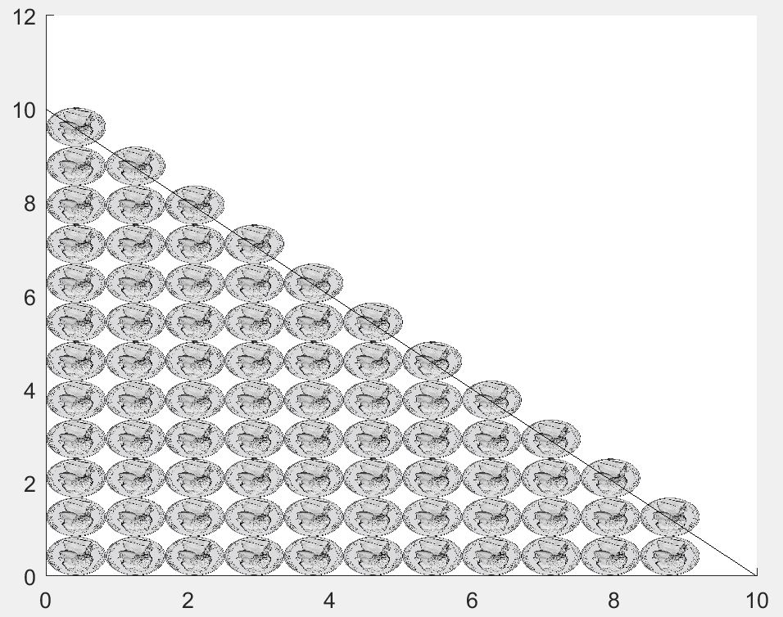

### **Figure 2.3:** Estimating Area of Graph Using Nickels

Notice how there is less white space between these 77 nickels in Figure 2.3 than there were between the quarters in Figure 2.2. While there is some excess area from the coins outside of the triangle, the main thing to focus on is the decrease in space between the coins. Now, let’s go even smaller. Let’s use dimes to measure the area of the triangle as seen below in Figure 2.4.

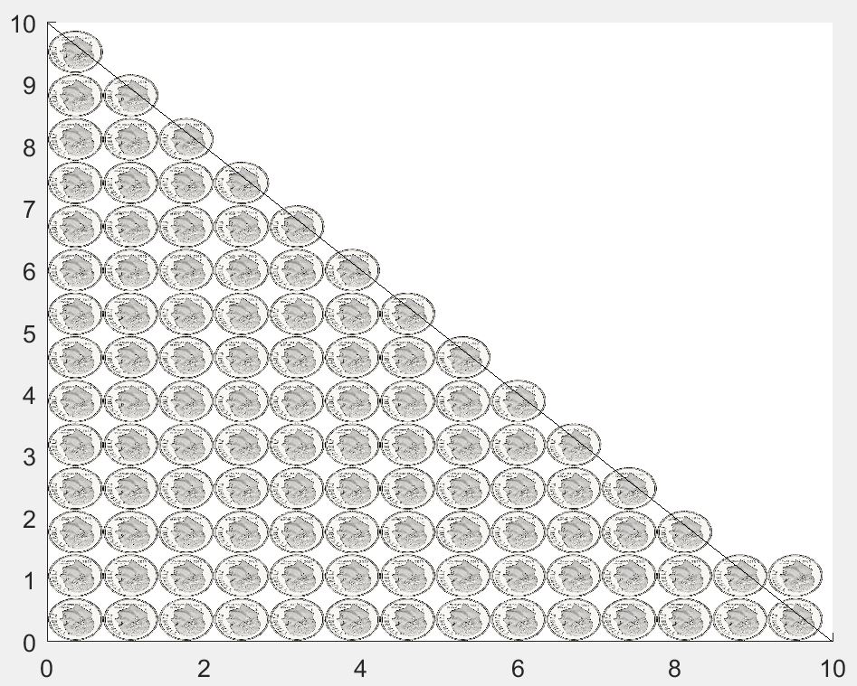

### **Figure 2.4:** Estimating Area of Graph Using Dimes

There is even less space between the 106 dimes than there were between the nickels. If we keep making the object that we’re using to measure the triangle’s area smaller and smaller, then the sum of the areas of those small objects will continually move towards the true area of triangle. As the object’s size becomes infinitesimally small (1/∞), then the sum of all of the objects’ areas will equal the true area of the triangle.

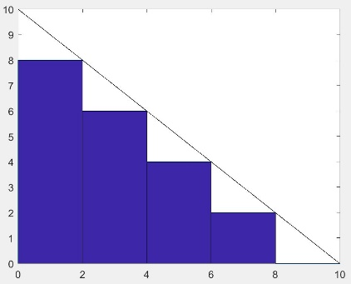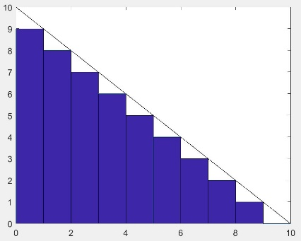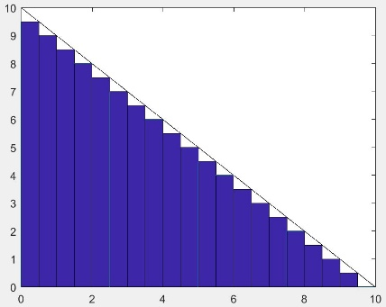Let us now switch to rectangles as the object used to measure the area under a curve. Below you will see a set of pictures that show rectangles filling up the area under the curve. The number after the letters is the number of rectangles used to estimate the sum of the area under the curve in each picture.

**a = 5**

**b = 10**

**C = 20**

### **Figure 2.5:** Pictures Showing Rectangles Filling Area Under the Curve

As the width of the rectangles get smaller, the total area covered by the rectangles increases and the amount of white space decreases. This is very similar to how we made our coins smaller so that there was less white space between each coin. If there is less white space, then that must mean that our estimation is getting closer to the actual area of the triangle. Furthermore, if we continue to decrease the width of our rectangles so that they were infinitely small, then our estimation of the area under the curve will equal its true value. Below is a figure that shows what it would look like if we had an infinitely large number of rectangles underneath the curve (Figure 2.6).

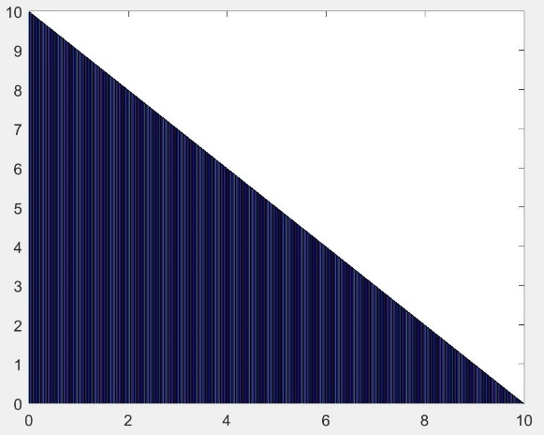

### **Figure 2.6:** Infinitely Large Number of Rectangles Under the Curve

For visual purposes, the red line in the triangle shows what one rectangle would look like. However, in reality, if there were an infinitely large number of rectangles under the curve, then that would mean that each rectangle would have a width of (1/∞). That means that you would not be able to see one single rectangle. Instead, you would see the infinite sum of all of those rectangles, which would be the area under the curve. In other words, the infinite sum of the areas of all of those rectangles with infinitely small widths would be the integral of the curve.

# **Summary**

The concept of how infinity can represent something really large (∞), but also something really small (1/∞) is crucial to understanding the concepts of both derivatives and integrals. In derivatives, when two points are infinitely close together such that the distance between them is infinitely small, then the change between those points, or the slope, is the derivative of the line at those points. In integrals, when the sizes of objects used to measure the area, or volume, of something is infinitely small, then the sum of the space occupied by an infinite amount of those objects is the area, or volume, of that thing.

Understanding the ideas of calculus makes it infinitely easier to understand its applications within our world. It requires a different way of thinking about mathematics and the world, but in going through this, it enables one to put the world into perspective and achieve a greater understanding and appreciation of it.

This document serves as an introduction to the ideas of calculus, but by no means does it cover them in their entirety. For further learning into these ideas, I would first recommend taking a moment to internalize the ideas stated above. Visualize them. Attempt to apply them to things in your life. Try to explain them to someone else. Doing this will further your own understanding of the topics and allow you to understand them on a deeper level. For learning from other resources, I would recommend navigating the Internet and reading online articles on the subject, including articles written on forums. Someone else’s explanation may help you understand the topics in a way that you didn’t before. Other resources include calculus textbooks and biographies on the people who derived these ideas. The culmination of all of this knowledge is yours to explore.